**IT24103033**

**Dinuwara K.D.S**

**PS Lab 7**

**Exercise**

**1.**

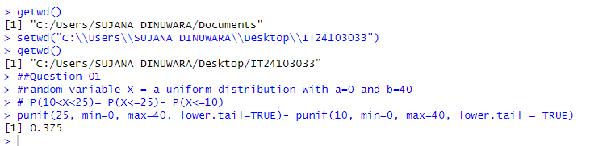

**2.**

**3.**

**i.**

**ii.**

